**Visit us at: imru1237.com**

**This leaflet is personally delivered to you to invite you on an exploration. At the center of Project imru1237 are four themes with specially designed logos, each crafted to resonate with the core values of The Word and in our virtual ministry.**

**Find us on YouTube and Tik Tok @imru1237**

**LoveOne: The Foundation of Our Belief imru: The Call to Action**

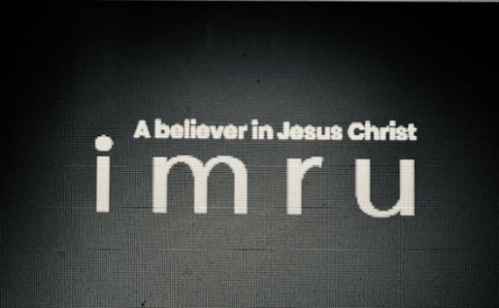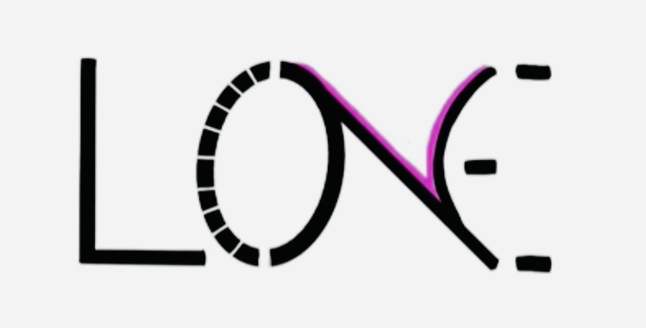

Exemplifies: LOVEONE GOD--LOVEONE ANOTHER "A believer in Jesus

Christ. I am. Are you?"

**1237 Color Code in Bible**

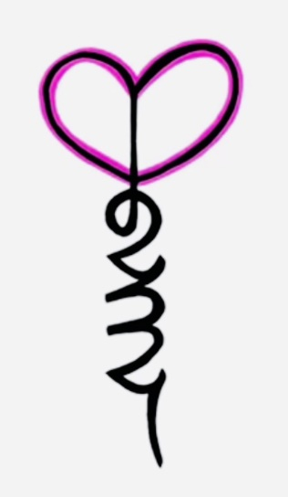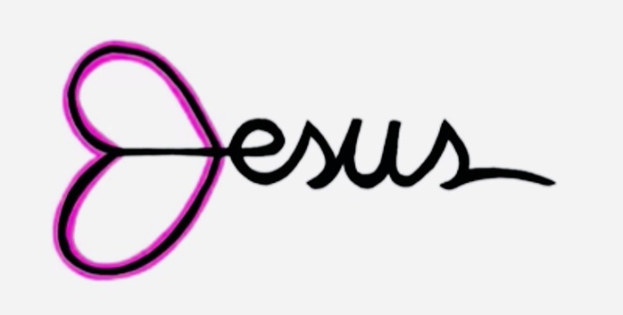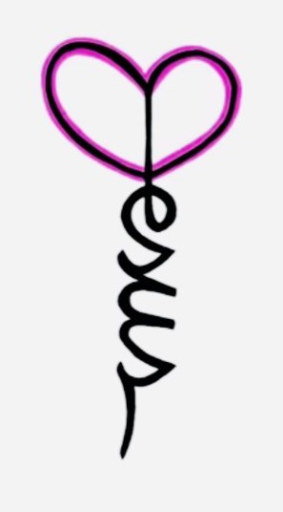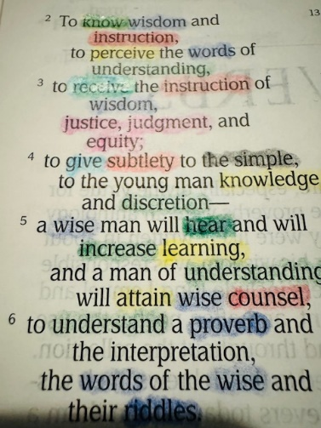 When you view our logo featuring ‘Jesus’ in cursive The Color Code Revealed

and hold it up to a mirror, a revelation occurs: 1237 in The Bible, through the

has been hidden in Jesus name for all these ages. It felt Seven Spirits of God.

divinely ordained. We endeavor to use it as a teaching tool. -NEW discovery-

**These images serve not only as a reminder of our mission but also as a testament to how God reveals truths through unique and unexpected means--whether it be through cursive handwriting, the simple elegance of numbers, or insight into the light of His Word revealed in colors.**

**All Logos/Slogans Trademarked, Text Copyrighted Welcome to: imru1237.com**